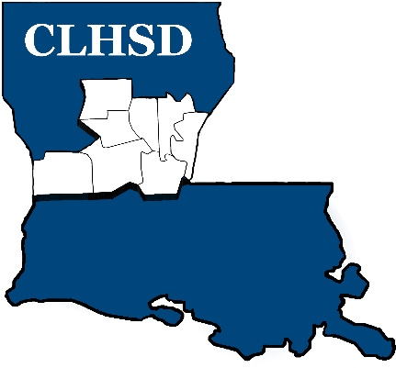

PUBLIC NOTICE

The Board of Directors of Central La Human Services District will conduct its monthly meeting on:

Thursday, October 7th
5:30 p.m.

Office of Public Health ~ Conference Room
5604 Coliseum Blvd., Bldg. B
Alexandria, LA 71303

The meeting is open to the public

